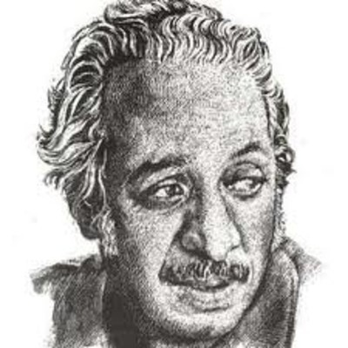

Abdel Sabour, Salah (1931 –1981)

Salah Abdel Sabour (also Abd-al Sabur) is an Egyptian writer, poet, and playwright. He is considered a pioneer of modern Arabic poetry and a prominent figure in Arabic modernism and the Arabic free verse movement.

Born in a small town in the Eastern Delta of Egypt in 1931, Abdel Sabour showed an interest in literature at a young age. He began writing verse at the tender age of thirteen. His talent reached full maturity by the 1950's. Though his regular education enabled him to develop an appreciation for the long tradition of classical Arabic poetry, his modern sensibility was sharpened through readings in European poetry, especially that of symbolists Rilke and Baudelaire and the English poetry of Donne, Yeats, Keats and T.S. Eliot. He was also influenced by prominent Arab Sufis such as Al- Mutanabbi and Persian mystic poet and Sufi writer Mansur Al-Hallaj.

He graduated from the Department of Arabic Language, at the Faculty of Arts, Cairo University, in 1951. In 1957 his first collection of poetry Al-Nass Fi Biladi (People of my Country) using free verse was published catapulting the poet into fame. It caught both readers’ and critics’ attention alike for its use of unique imagery and everyday common language. It broke away from the constricting rigid structure of Arabic classical poetry. The restrictions of number of feet per line and rigidity of rhyme were no longer issues with the free verse movement which started in Europe. Abdel Sabour put to use this new, flexible verse form which allowed for dramatic poetry and which he refined to use in his poetic drama.

Ma'sat Al-Hallaj (The Tragedy of Al-Hallaj), one of his best-known poetic dramas, infuses myth and folklore with mysticism and existentialist thoughts. It was written in free verse as Abdel Sabour believed this form allowed for spontaneity. The play deals with the trial and execution of Mansur al-Hallaj (c. 858AD-922AD), a mystic Sufi poet and political agitator during the end of the Abbasid Dynasty. The will of the individual, Al-Hallaj, is set in opposition to the corrupt politicized religious will of the ruler of Baghdad. Al-Hallaj’s faith in Divine power stands in contrast to authority’s brand of faith.

Another notable example of Abdel Sabour’s drama is his poetic play Layla wa-al Majnun (Laila and the Madman) a politically charged play which takes place during the months before the 1952 Egyptian “Revolution.” The play presents a mélange of poetic styles; the free verse of Abdel Sabour representing the dramatic dialogue of the play, Ahmad Shawqi’s classical verse from his play Majnun Layla (Layla’s Madman) incorporated into the plot of Abdel Sabour’s play and which the characters are rehearsing, intermixed with the colloquial Arabic songs of popular Egyptian singers. A gloomy existentialist outlook colours Abdel Sabour’s play: the final madness of the protagonist and a revolution in the making end the play on a melancholic and ambiguous, uncertain note.

Salah Abdel Sabour’s verse and poetic plays exhibit a talent for mixing the absurd, the modern, the mythical and the mystic. He experimented with language in verse, freeing it from restrictions and confinements. He used those tools to depict modern man’s dilemma and the fragmentation of modern experience.

List of Works:
Poetry
Al-Nass fi Biladi (People of my Country), 1957
Aqula Lakum (I Tell you this), 1961
Ahlam Al-Faris Al-Qadim (Dreams of the Old Knight), 1964
Ta'amulat fi Zaman Jarih (Meditations on a Wounded Time), 1970
Shajar Al-Layl (Trees of the Night), 1973
Al-Ibhar fi-AlDhakira (Sailing in Memory), 1977
Plays
Ma'sat Al-Hallaj (Tragedy of Al-Hallaj or Murder in Baghdad), Arabic version was published in 1964 English version in 1972.
Musafir Layl (Night Traveller), 1968
Al-Amira Tantazir (The Princess Waits), 1969
Layla wa-al Majnun (Layla and the Madman), 1971
Ba'd an Yamut Al-Malik (After the King Dies), 1975
References and Further Reading:
Attar, Samar. The Influence of T.S. Eliot on Salah Abdel Sabour. Diss. Dalhousie
University, 1967. Print.
Jayyusi, Salma Khadra, ed. Modern Arabic Poetry: An Anthology. New York: Columbia
University Press, 1987. Print.

Sally Hammouda

